IT/CS Workshop (ICW) USER MANUAL

Introduction
The IT/CS Workshop (ICW) is a web based authoring system designed for use by teachers in the education field. The main purpose of the system is to create a new paradigm of computer-aided learning. The system will work by creating a course page with information such as text, videos, audio etc. which will be exported as a course page for use by the students. The authoring system for the course page will have the ability to upload various content such as inline equations, the ability to upload video, audio and the ability to link to other course pages. The overall goal of the system is to revolutionize the way in which students are taught, they will no longer be fed information without an analytical background instead they will be taught about what, when, where and why they are being taught the information.
Features
- In-Line Equations
- Text Justification(full,right,left,center)
- Block quote(indent paragraph on both sides
- Font Selection
- Video displayed-in your face mode
- Video displayed-discrete mode
- Audio displayed-in your face mode
- Audio displayed-discrete mode
- Anchoring within project
- Hyperlink to external file(course,topic,etc)
- Hyperlink Mode to display pop up element
- Highlight project currently in

Getting Started
The user will begin by logging on to the system website: icw.cise.ufl.edu. Before the user can use any of the website’s features they will have to create a user account.

Creating a User Account
The user will need to enter their first and last name followed by their email. They should also enter a unique user name and password which will be required every time the user is logging in. After entering this information the user must ensure that they check the box which says admin if they which to edit course content.
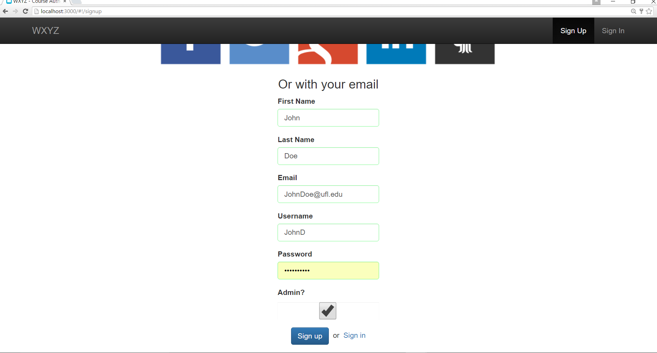Figure 1-Shows how to create a user account

Creating a New Project
The system will work by allowing the user to create projects under which they will be able to create different courses. In order to create a project they will simply click at the top left of the page, File-New and a new project will be open where they can enter a project title and a description for the project.
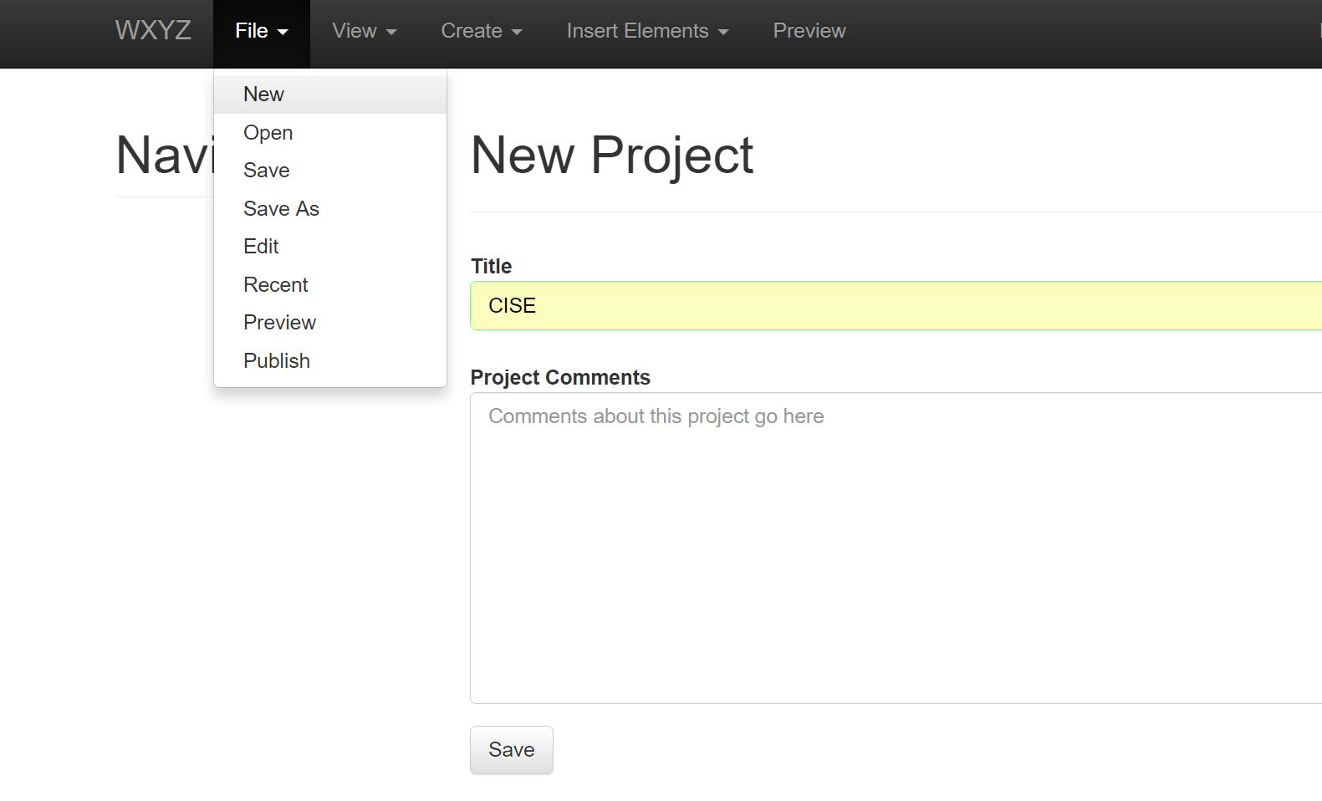
Figure 2-Shows how to create a new project
Creating a New Course
After creating a new project the user will be able to create a new course. In order to create a new course click the create tab at the top of the screen and click course. After creating a course the user will be able to create new topics, concepts, quizzes etc.

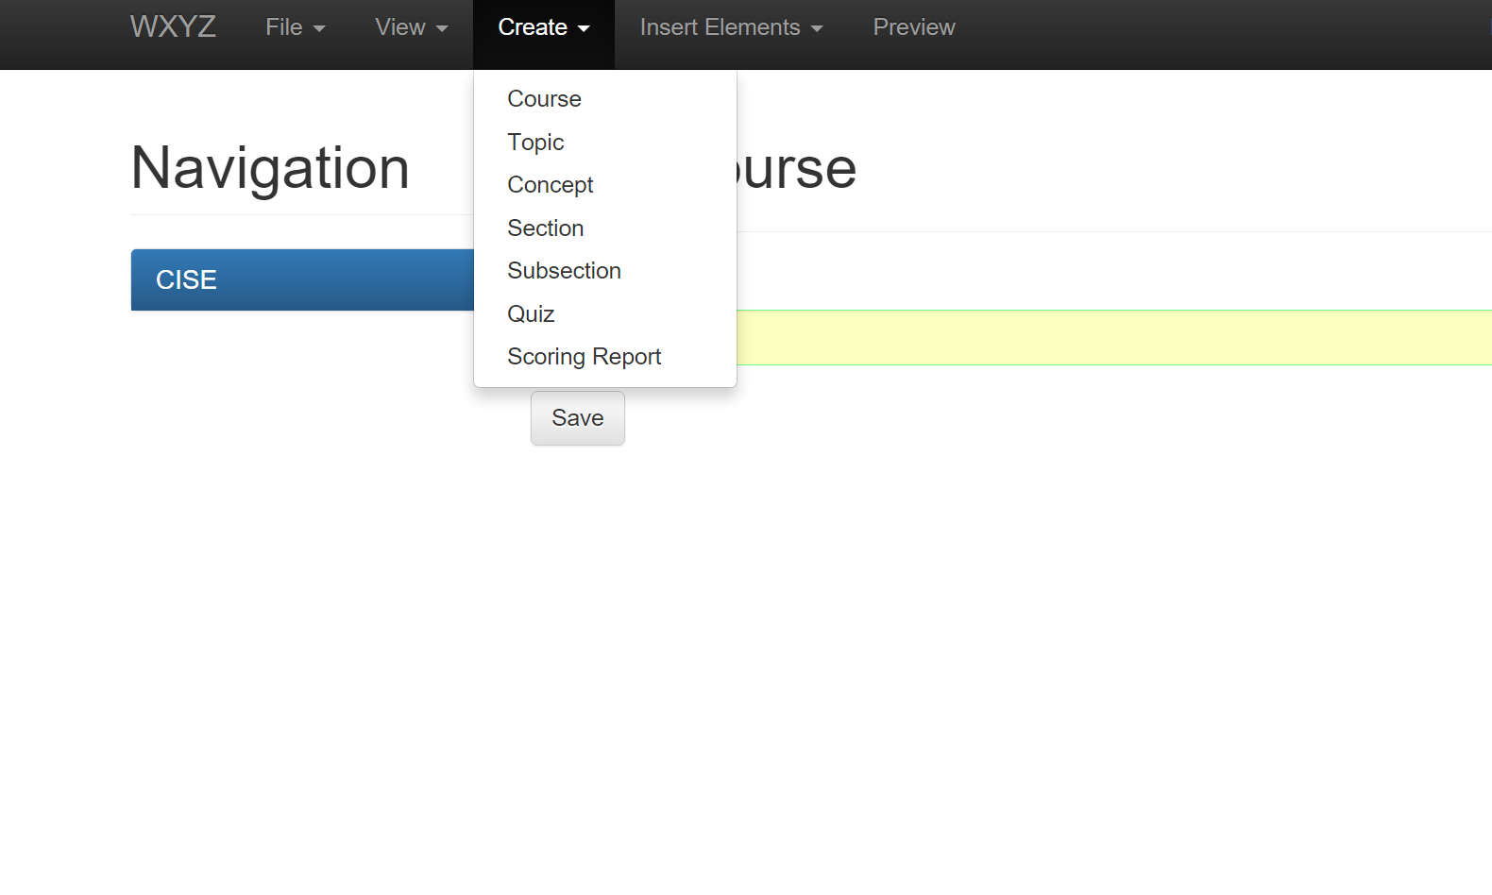
Figure 4-Shows how to create a new course
Adding Text
In the ICW text can be added to elements such as courses, topics, concepts. The ICW system uses a plugin based text editor known as ck editor. This editor allows the user to use standard features which are included in most text editors such as: Bold, Italic, Underline, align left, align right, subscript etc. To add text to a course the user should click the course they wish to add it to, and click the Insert Elements tab at the top of the page and then click text. The ck editor will then pop up and the user will be able to add the text they write directly into the text box.
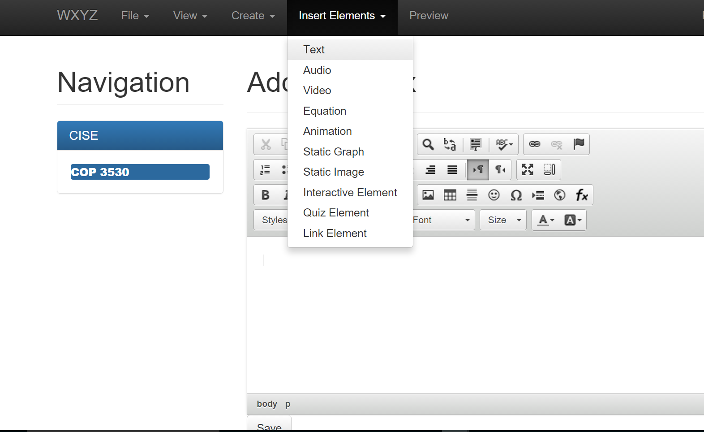
Figure 3-Shows the user how to insert text

Adding In-Line Equations
The text editor, ck editor used for the ICW system has the ability to add In-Line equations. The user should simply just simply click the Insert equation button which is shown in the figure below.
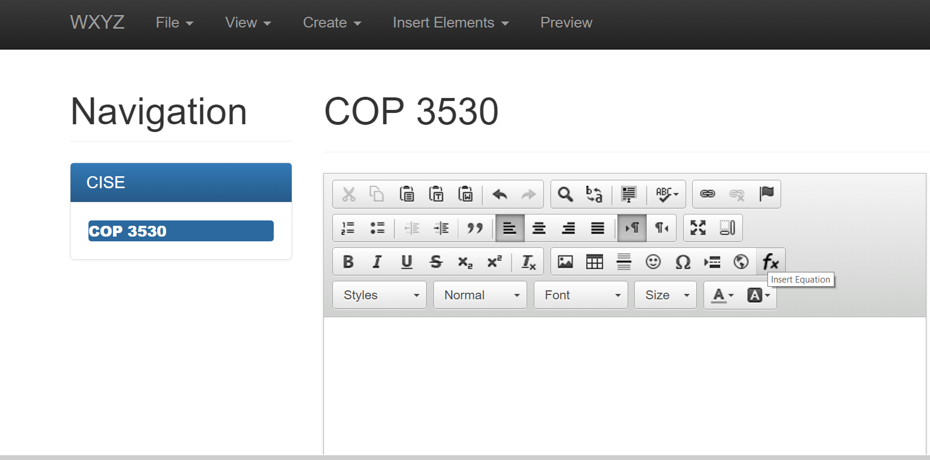
Figure 4-Shows the user the Insert Equation button

After clicking the insert button a new text box will appear with the various symbols used to create equations the user can simply just click and type the variables and equations they need. As they type a preview will appear at the bottom of the screen showing how it will appear in the text element of the course.

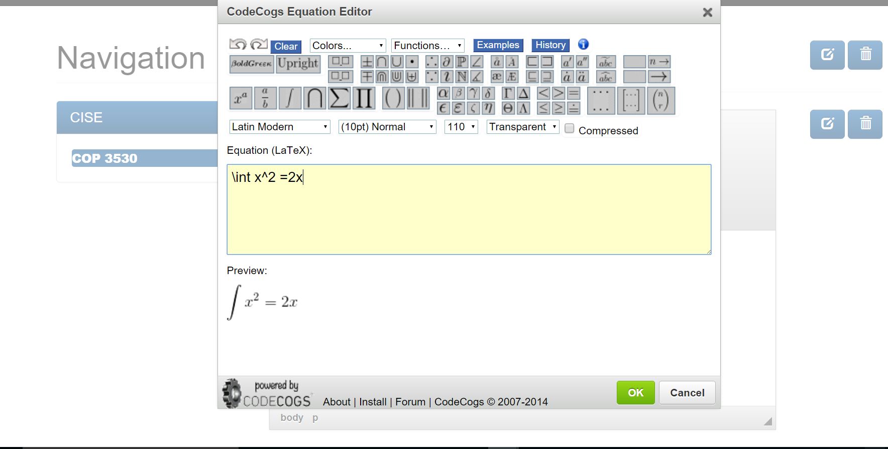
Figure 5-Shows the user the insert Equation textbox along with the preview

After typing the desired equation the user can click the ok button. Then the original text box will reappear and they can continue writing text as normal, hitting the save button once they are finished. The results will be as displayed below.
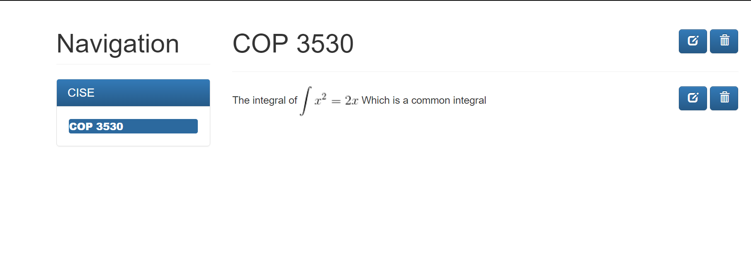
Figure 6-Shows the end result of adding an In-Line Equation

Anchoring Within a Project
The ck editor has the ability to anchor text within a project. In order to anchor the user should first highlight the text they wish to anchor to, then click the anchor button in the toolbar menu and give it a unique anchor name.
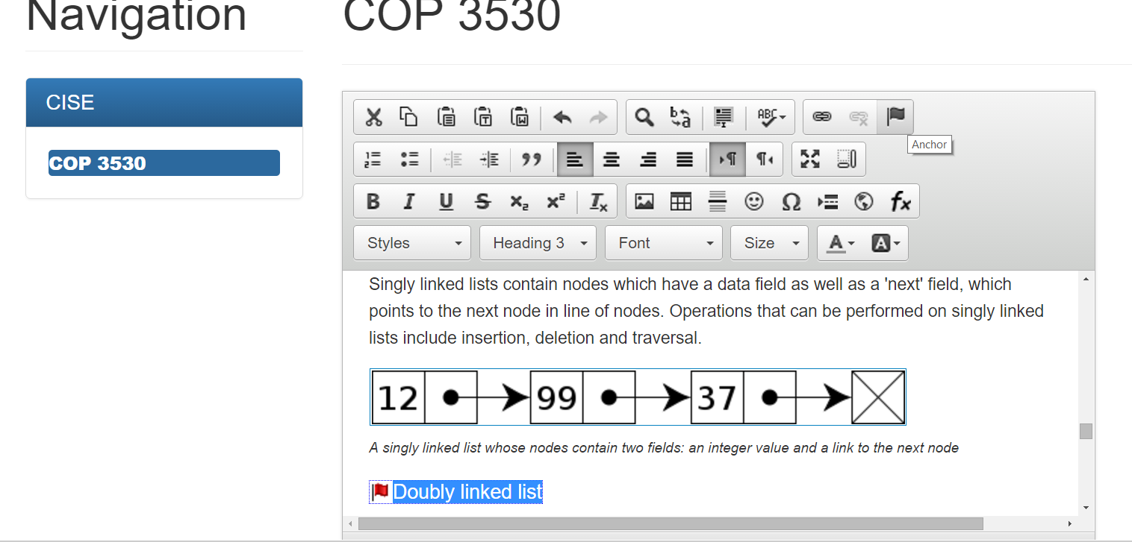
Figure 7-Shows the user how to highlight an anchor and the location of the anchor button

After giving it a unique name the user can link to a specific anchor by copying the text they wish to be the link and clicking the link button in the toolbar menu.
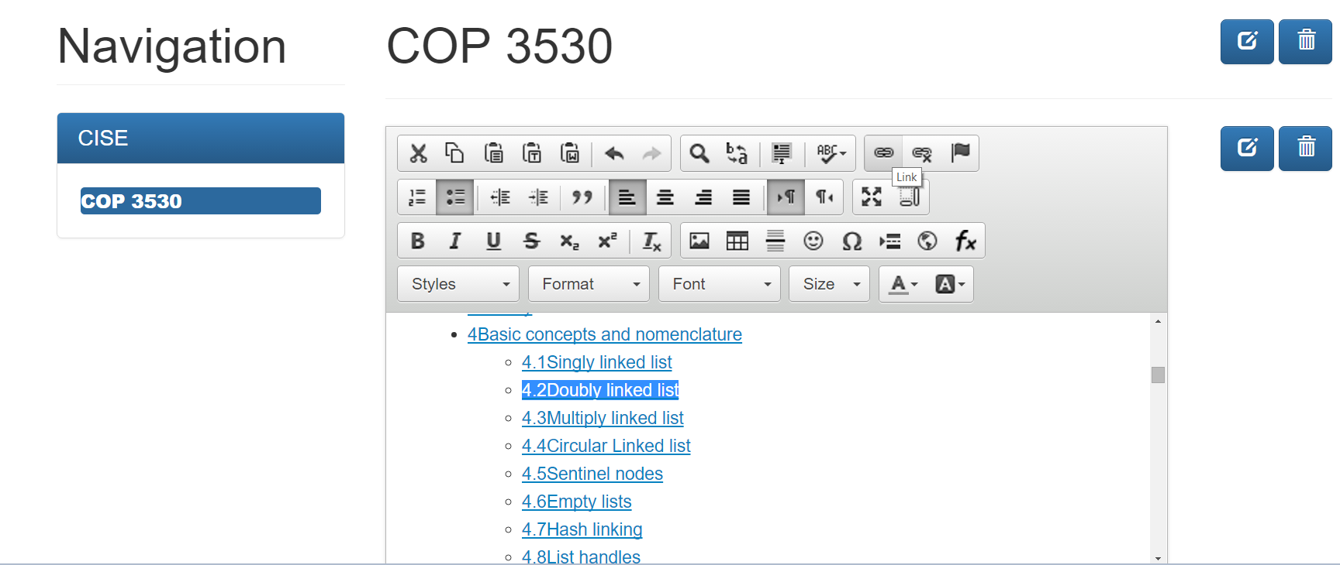
Figure 8- Shows the user the location of the link button.
Then under the link type heading click the option “link to anchor in the text”.
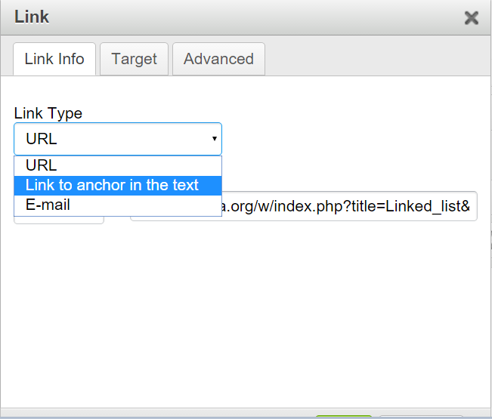
Figure 9-Shows the user the location of the “link to anchor in the text” option.

Then under anchor name click the anchor name you desire and click the ok button
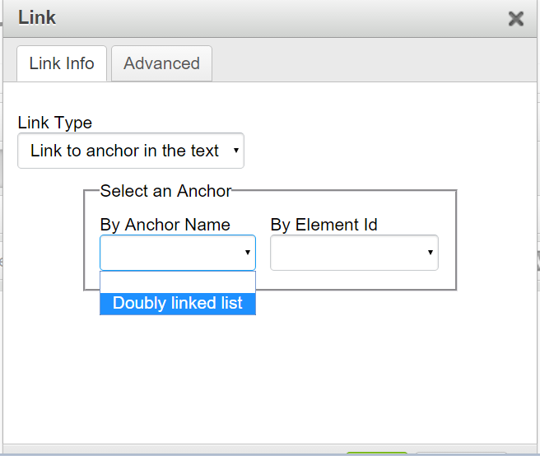
Figure 10 shows the user how to choose an anchor link name.
Your anchor link is now created and after clicking the specific link should scroll down to the specific area in the text.

